Shell Script

Shell is a software program that acts as a mediator between the kernel and the user. It reads the commands and interrupts by sending requests to execute a program. So, the shell is known as a command interpreter.
It contains almost 100 system calls. It tells the kernel to carry out various tasks for the program. These tasks are as follows −
• Opening a file.
• Writing a file.
• Obtaining information about a file.
• Executing programs.
• Terminating a process.
• Changing the priority of processes.
• Getting the time and date.

Automate daily Backups.
Monitor system periodically .
Raise alarms and send notifications.
Trobleshooting and Audits.
Automate Installation and Patching of software on multiple servers.

rocket-add
rocket-start-power
rocket-internal-power
rocket-start-sequence
rocket-start-engine
rocket-lift-off
rocket-status
Shell Scripting:
Write a script by opening Vi editor(Write a sequence of commands) .
Export PATH:$PATH:/home/bob to execute the file without.sh extension. And give acces to execute permssions.
which fileName to see location.

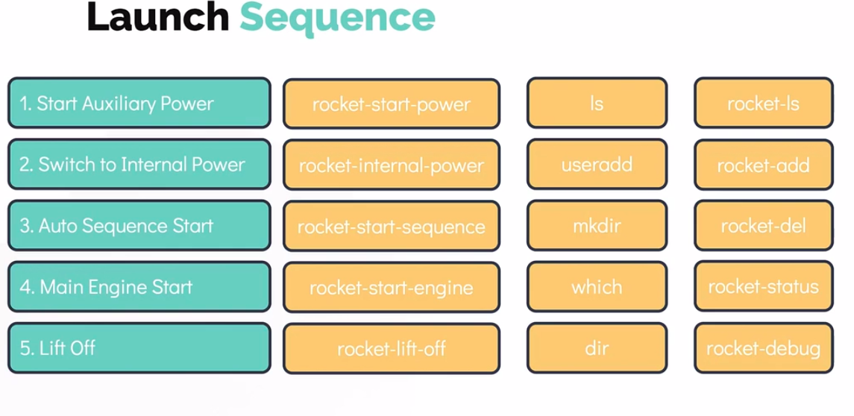

Variables:
mission_name=lunar_mission

variabels ====>>> $mission_name

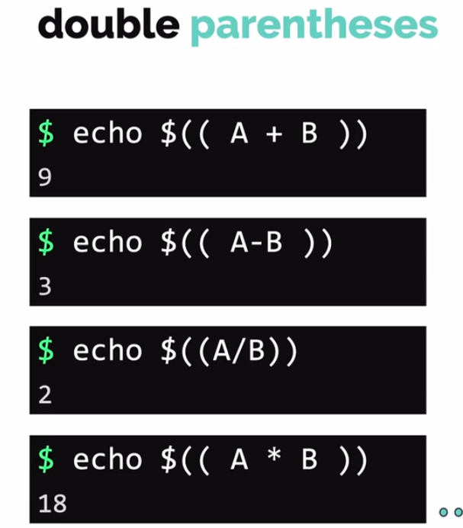

command line Argument:

create-and-launch-rocket jupiter-mission
( $0 ) ( $1 )

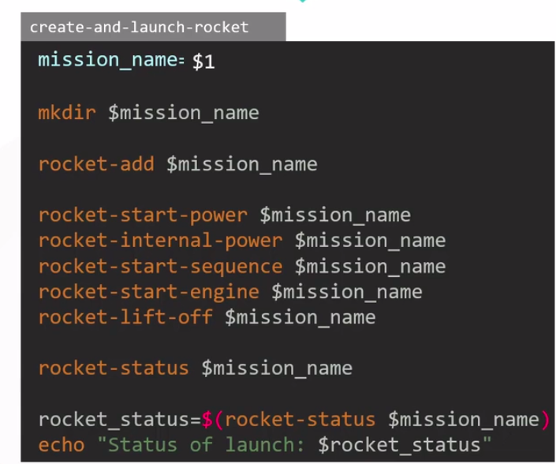

Read inputs:reading the input for command line .

read mission_name;

read -p “ Enter mission name: ” mission_name;

Arithmentic operations:
expr 6 + 3 {Strictly separated by space}.

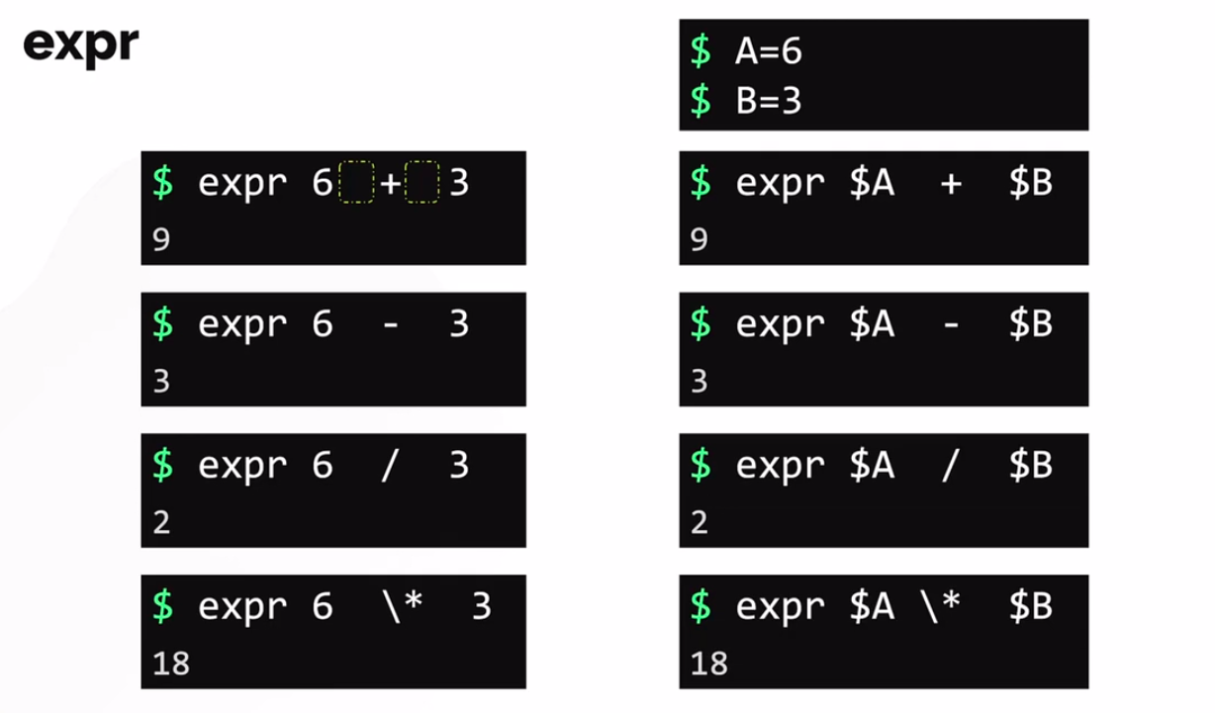

For getting floating points: echo $A + $B | bc – l

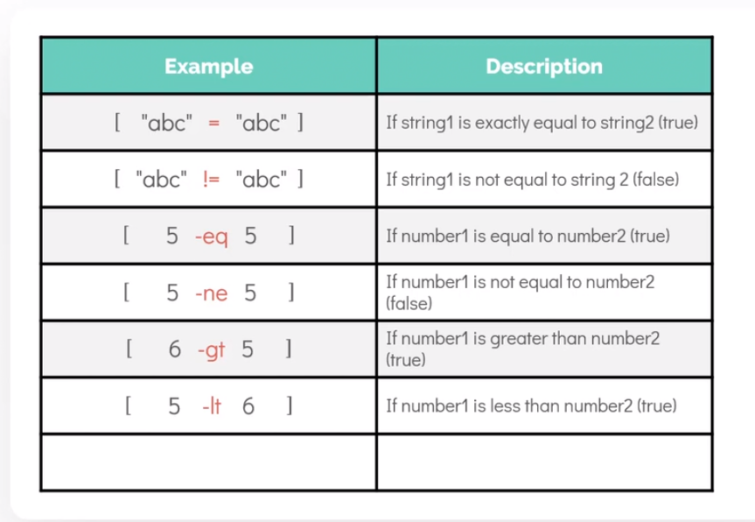

Conditional operators:

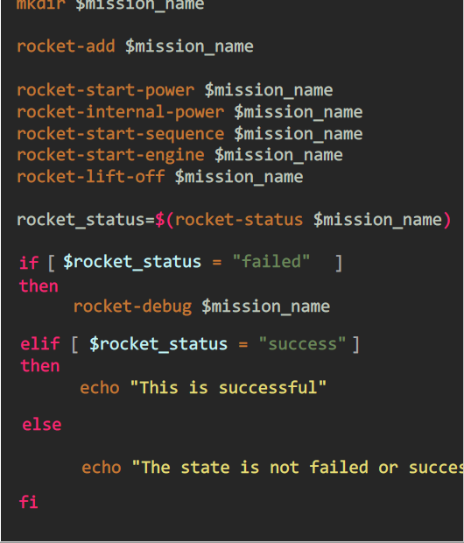

Loops:

for loops can be written in multiple ways:

for mission in <list of missions>
do
create-and-launch-rocket $mission
done

for mission in 1 2 3 4 5 6
do
create-and-launch-rocket $mission
done

for mission in 1 2 3 4 5 6
do
a= $mission * $mission
echo $a
done

for mission in {0..100}
do
create-and-launch-rocket $mission
done

for mission in {0..25}
do
echo $mission
done

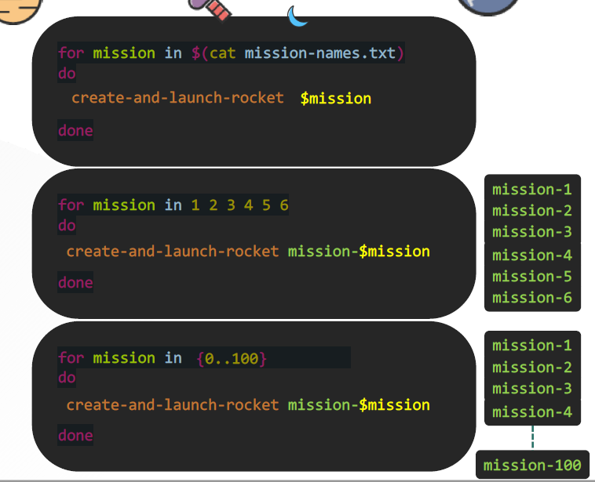

While Loop:
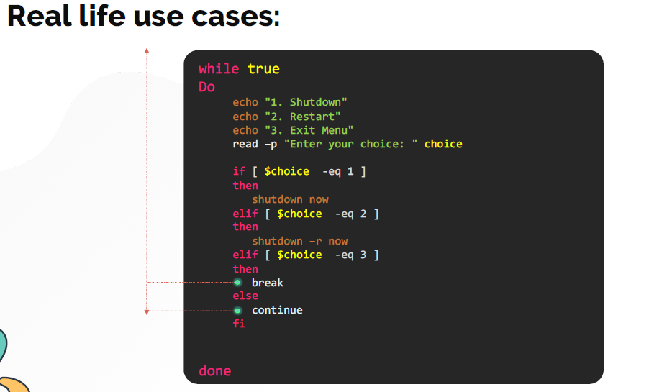

Switch case:

Exit-Codes and different types of Exit Codes.

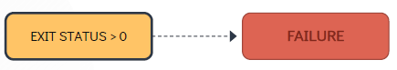

echo $? = to check the exit status.

Functions:

When a shell script runs it runs line-by-line. So your Function must always be defined first before calling it, if not then it will give error.
- The return statement within a function call helps in specifying the exit code for that function. It is just like the exit code for the entire script but in this case it wont exit the script but the function.

function add(){
sum=$(( $1 + $2 ))
echo $sum
}

result=$(add 3 5)
echo "The result is $result"

function printstring(){

echo $(( $1 + $2 ))
}
res= $( printstring 13 15 )
echo "gigigi"
echo res?

ShellCheck

System Services;

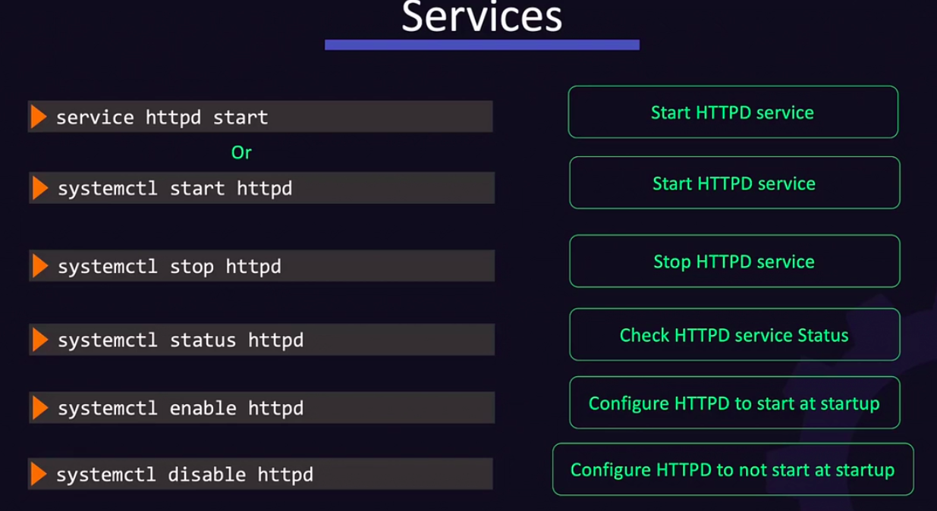

CRON JOBS:

Assignment

min hour date month day

0 9,15 * * 1-5 command()

